SRSP-310.7
Issue 5
DRAFT 1 June 2026

Spectrum Management and Telecommunications

Standard Radio System Plan

Technical Requirements for Fixed Line-of-Sight Radio Systems Operating in the Band 10.7-11.7 GHz

Preface

Standard Radio System Plan SRSP-310.7, issue 5, Technical Requirements for Fixed Line of-Sight Radio Systems Operating in the Band 10.7-11.7 GHz, replaces SRSP-310.7, issue 4.

The following are the main changes:

- The radio frequency (RF) channel arrangement was updated to add channels covering the sub-bands 11.075 – 11.2 GHz and 11.575-11.7 GHz, consistent with the Decision on Request Received from Telesat Spectrum General Partnership for continued operation of Anik G1 at 107.3°W in extended Ku-band frequencies (11.075 – 11.2 GHz and 11.575-11.7 GHz).

- Redundant requirements already covered by SRSP-300-Gen were removed.

- Some outdated technical provisions providing additional restrictions in congested areas have been removed.

- Other editorial changes and clarifications have been made throughout the document.

Issued under the authority of
the Minister of Innovation, Science, and Economic Development

____________________________________
Wen Kwan
Director General
Engineering, Planning and Standards Branch
Contents

1. Intent 1

2. General 1

3. Related documents 2

4. Radio frequency (RF) channel arrangement description 3
4.1 10 MHz channel spacing 4
4.2 20 MHz channel spacing 4
4.3 30 MHz channel spacing 5
4.4 40 MHz channel spacing 5
4.5 60 MHz channel spacing 6
4.6 80 MHz channel spacing 6
4.7 Closed loops 6
4.8 Assignment of frequencies 6
4.9 Spectral efficiency 7

5. Transmitter characteristics 7

6. International coordination 9

7. Antenna characteristics 9

8. Maximum equivalent isotropically radiated power 13

9. Avoidance of the geostationary satellite orbit 13

Annex A — 11 GHz band plan for systems using a common transmit/receive separation of 490 MHz 15

1. Intent

This Standard Radio System Plan (SRSP) states the minimum technical requirements for the efficient use of the frequency band 10.7-11.7 GHz by point-to-point radio systems in the fixed service.

This SRSP is intended to be employed in the design and specification of radio systems and equipment and in the evaluation of technical applications for new radio facilities or modification to radio systems submitted in accordance with the current issue of Radio Standards Procedure (RSP) 113, Application Procedures for Planned Radio Stations Above 960 MHz in the Fixed Service.

This SRSP must be used in conjunction with SRSP-300-Gen, General Technical Requirements for Fixed Radio Systems Operating in Frequency Bands above 960 MHz, for assessing compliance with Innovation, Science and Economic Development Canada (ISED) requirements. Certain technical requirements which were found in the previous issue of SRSP-310.7 are now addressed in SRSP-300-Gen. Fixed point-to-point radio systems in the frequency band 10.7-11.7 GHz shall comply with both the requirements of this SRSP as well as those prescribed in SRSP-300-Gen. Where requirements in SRSP-300-Gen are different from those in this SRSP, this SRSP shall take precedence.

This SRSP specifies equipment characteristics related to efficient spectrum usage only and is not to be regarded as a comprehensive specification for equipment design and/or selection.

2. General

Existing radio systems that were licensed as standard prior to the issuance of this SRSP may continue to operate as standard. Extension, expansion, or modification of these systems will be considered by ISED on a case-by-case basis. New systems deployed shall conform to the requirements of this standard.

Some requirements in this technical standard make reference to spectrum congestion levels. The criteria for determining congestion levels are described in the Geographical Differences Policy Guideline found in part B, section 1.6 of Spectrum Utilization Policy SP 1-20 GHz, Revisions to Microwave Spectrum Utilization Policies in the Range of 1-20 GHz.

3. Related documents

The current issues of the following documents are applicable and available on the Spectrum Management and Telecommunications website:
SRSP-300-Gen | General Technical Requirements for Fixed Radio Systems Operating in Frequency Bands Above 960 MHz
Arrangement A | Arrangement between the Department of Transport and the Federal Communications Commission for the Exchange of Frequency Assignment Information and Engineering Comments on Proposed Assignments along the Canada-United States borders in certain bands above 30 Mc/s
CPC-2-0-03 | Radiocommunication and Broadcasting Antenna Systems
DGTP-001-02 | Consultation on Revisions to the Spectrum Utilization Policies in the 3-30 GHz Frequency Range
SMSE-004-26 | Decision on Request Received from Telesat Spectrum General Partnership for continued operation of Anik G1 at 107.3°W in extended Ku-band frequencies (11.075 – 11.2 GHz and 11.575-11.7 GHz)
RSP-113 | Application Procedures for Planned Radio Stations Above 960 MHz in the Fixed Service
TRC-43 | Designation of Emissions, Class of Station and Nature of Service
CTFA | Canadian Table of Frequency Allocations
SP 1-20 GHz | Revisions to Microwave Spectrum Utilization Policies in the Range of 1-20 GHz
SP 3-30 GHz | Revisions to Spectrum Utilization Policies in the 3-30 GHz Frequency Range and Further Consultation
____________________________
CPC – Client Procedures Circular
RSP – Radio Standards Procedure
SRSP – Standard Radio System Plan
SP – Spectrum Utilization Policy
TRC – Telecommunications Regulation Circular

4. Radio frequency (RF) channel arrangement description

The radio frequency channel arrangements defined in this standard provide for six different RF channel spacings. Channel pairs are provided with a common transmit/receive separation of 490 MHz. These arrangements apply across the entire frequency range 10.7-11.7 GHz comprising a lower block (10.7-11.2 GHz) and an upper block (11.2-11.7 GHz). This SRSP supports the following RF channel spacings: 10, 20, 30, 40, 60 and 80 MHz. Moreover, the tables in annex A provide the RF channel frequencies.

4.1 10 MHz channel spacing

The centre frequencies of the 49 paired channels that allow RF channel bandwidths of 10 MHz or less are expressed by the following relationships:

Lower half of the band A_{n} = 10705 + 10n for n = 1 to 49
Upper half of the band A'_{n} = 11195 + 10n for n = 1 to 49

where n is the channel number and A_{n} and A'_{n} are the centre frequencies (in MHz) of the paired channels.

Note: Additional channel assignments at 10705 MHz and 11695 MHz may be employed for one-way operation.

4.2 20 MHz channel spacing

The centre frequencies of the 24 paired channels that allow RF channel bandwidths of greater than 10 MHz and less than or equal to 20 MHz are expressed by the following relationships:

Lower half of the band B_{n} = 10700 + 20n for n = 1 to 24
Upper half of the band B'_{n} = 11190 + 20n for n = 1 to 24

where n is the channel number and B_{n} and B'_{n} are the centre frequencies (in MHz) of the paired channels.

Note: An additional channel assignment at 11690 MHz may be employed for one-way operation.

4.3 30 MHz channel spacing

The centre frequencies of the 16 paired channels that allow RF channel bandwidths of greater than 20 MHz and less than or equal to 30 MHz are expressed by the following relationships:

Lower half of the band C_{n} = 10695 + 30n for n = 1 to 16
Upper half of the band C'_{n} = 11185 + 30n for n = 1 to 16

where n is the channel number and C_{n} and C'_{n} are the centre frequencies (in MHz) of the paired channels.

4.4 40 MHz channel spacing

The centre frequencies of the 12 paired channels that allow RF channel bandwidths of greater than 30 MHz and less than or equal to 40 MHz are expressed by the following relationships:

Lower half of the band D_{n} = 10695 + 40n for n = 1 to 12
Upper half of the band D'_{n} = 11185 + 40n for n = 1 to 12

where n is the channel number and D_{n} and D'_{n} are the centre frequencies (in MHz) of the paired channels.

4.5 60 MHz channel spacing

The centre frequencies of the 8 paired channels that allow RF channel bandwidths of greater than 40 MHz and less than or equal to 60 MHz are expressed by the following relationships:

Lower half of the band E_{n} = 10680 + 60n for n = 1 to 8
Upper half of the band E'_{n} = 11170 + 60n for n = 1 to 8

where n is the channel number and E_{n} and E'_{n} are the centre frequencies (in MHz) of the paired channels.

4.6 80 MHz channel spacing

The centre frequencies of the 6 paired channels that allow RF channel bandwidths of greater than 60 MHz and less than or equal to 80 MHz are expressed by the following relationships:

Lower half of the band F_{n} = 10675 + 80n for n = 1 to 6
Upper half of the band F'_{n} = 11165 + 80n for n = 1 to 6

where n is the channel number and F_{n} and F'_{n} are the centre frequencies (in MHz) of the paired channels.

4.7 Closed loops

When point-to-point digital radio systems form a closed loop, such systems shall be designed to consist of an even number of hops to permit the use of two frequency plans.

4.8 Assignment of frequencies

Consistent with the Decision on Request Received from Telesat Spectrum General Partnership for continued operation of Anik G1 at 107.3°W in extended Ku-band frequencies (11.075 – 11.2 GHz and 11.575-11.7 GHz), every effort must be made to assign new terrestrial links in the sub-bands 10.7-11.075 GHz and 11.2-11.575 GHz before making assignments in the sub-bands 11.075 – 11.2 GHz and 11.575-11.7 GHz. An applicant requesting use of the upper sub-bands will be required to provide technical justification for not employing the lower sub-bands.

Furthermore, new fixed service systems should normally use the lowest available frequency pair that can be successfully coordinated.

The use of co-channel dual polarization (CCDP) is both permitted and encouraged by ISED as a measure of increasing backhaul capacity while minimizing the need for additional spectrum. An applicant requesting the use of RF channel spacings of 60 or 80 MHz and not employing CCDP technology could be required to provide technical justification for not employing CCDP on a smaller RF channel spacing.

4.9 Spectral efficiency

In moderately congested and highly congested areas, digital systems submitted for licensing shall have a minimum spectral efficiency of 4.4 bits/s/Hz on a single polarization in a bandwidth corresponding to the channel spacing.

Outside of moderately congested and highly congested areas, digital systems submitted for licensing shall have a minimum spectral efficiency of 3.0 bits/s/Hz on a single polarization in a bandwidth corresponding to the channel spacing.

5. Transmitter characteristics

5.1 The transmitter power delivered to the antenna input per RF channel shall not exceed the limits for each bandwidth shown in table 1.

Table 1: Transmitter power limits

Bandwidth (BW) (MHz) | Power limits (watts) | Power limits (dBW)
20 < BW ≤ 80 | 10.0 | +10.0
BW ≤ 20 | 7.5 | +8.7

5.2 The centre frequency of the emission shall be maintained within ±0.003% of the assigned frequency.

6. Maximum equivalent isotropically radiated power

The maximum equivalent isotropically radiated power (e.i.r.p.) from the antenna shall not exceed +55 dBW per RF channel.

7. Antenna characteristics

In moderately congested and highly congested areas, the co-polarized radiation pattern envelope in the horizontal plane of the antenna must remain within Envelope A shown in figure 1 and table 2 for both vertical and horizontal polarizations.

Outside of moderately congested and highly congested areas, the co-polarized radiation pattern envelope in the horizontal plane of the antenna must remain within Envelope B shown in figure 1 and table 3 for both vertical and horizontal polarizations.

Table 2: Minimum antenna characteristics for the frequency band 10.7-11.7 GHz – Envelope A
Azimuth in degrees from the main lobe | Antenna directivity in dB down from the main lobe
0° | 0
1.5° | 0
2° | 17
3° | 17
4° | 23
15° | 32
20° | 34
50° | 45
100° | 70
180° | 70

Table 3: Minimum antenna characteristics for the frequency band 10.7-11.7 GHz – Envelope B
Azimuth in degrees from the main lobe | Antenna directivity in dB down from the main lobe
0° | 0
5° | 0
5° | 17
10° | 17
10° | 24
15° | 24
15° | 28
20° | 28
20° | 32
30° | 32
30° | 35
100° | 35
100° | 40
140° | 40
140° | 45
180° | 45

Figure 1: Minimum antenna characteristics for point-to-point digital radio systems operating in the frequency band 10.7-11.7 GHz
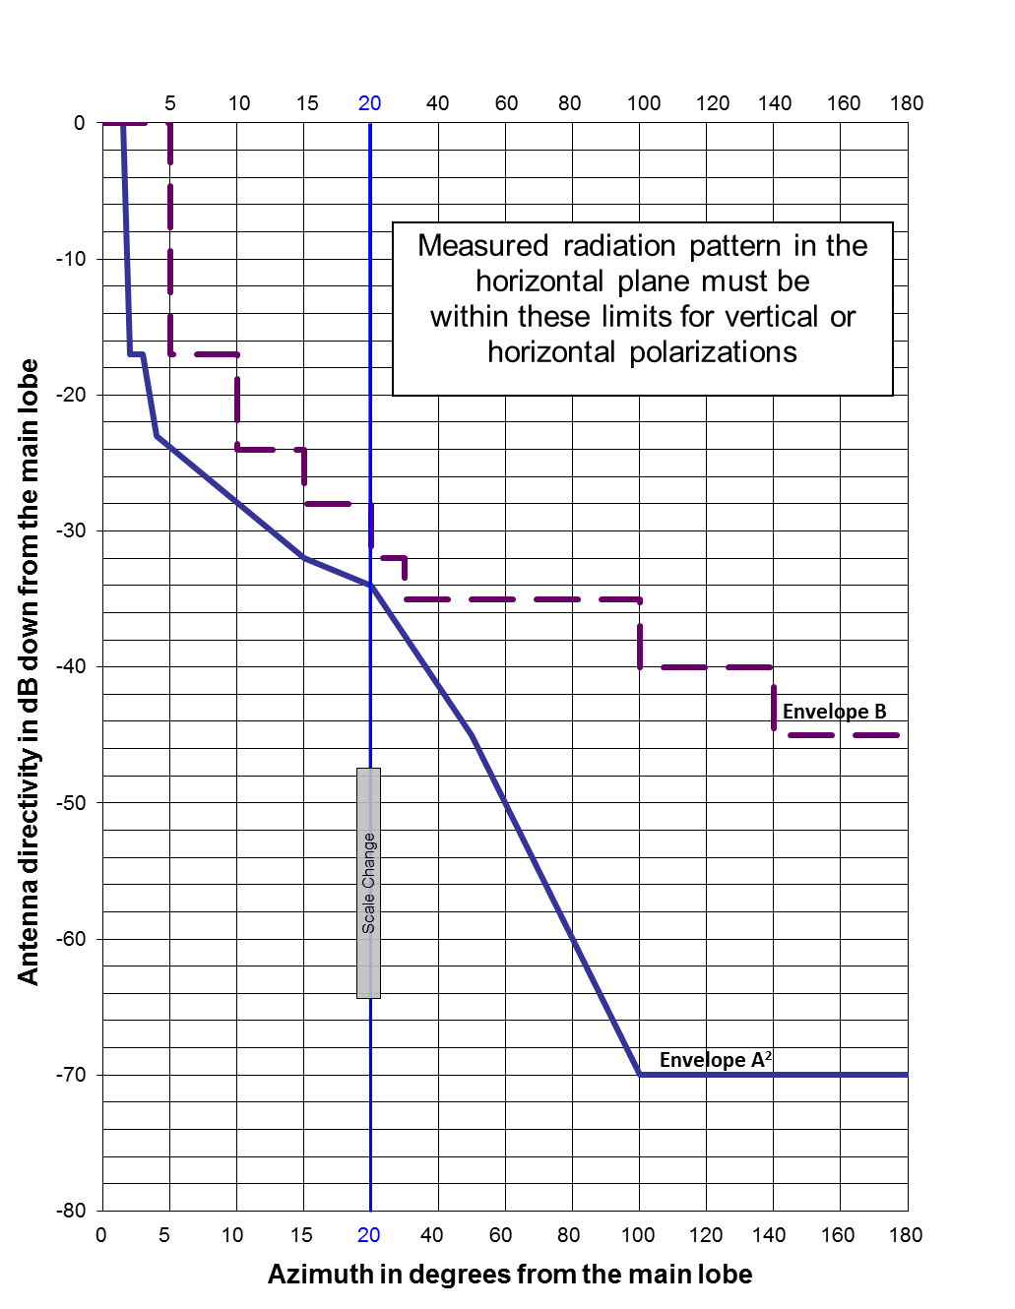

8. Avoidance of the geostationary satellite orbit

As guidance, to protect against geostationary-satellite space station emissions, new fixed service station receive antennas in the frequency band 10.7-11.7 GHz should avoid pointing towards the geostationary-satellite orbit, taking into account the effect of atmospheric refraction.

Note: ITU-R Recommendation SF.765 provides guidance on calculating the intersection of radio-relay antenna beams with orbits used by space stations in the fixed-satellite service.

9. International coordination

Stations operating in the frequency band 10.7-11.7 GHz near the Canada-United States border are subject to the provisions of Arrangement A.

Annex A — 11 GHz band plan for systems using a common transmit/receive separation of 490 MHz

The channel arrangement center frequencies specified in section 4 of this SRSP are listed in the tables below.

[See Excel workbook for Tables A.1 through A.6, to be inserted in the final document.]

