SRSP-312.7
Issue 2
October 2017

Spectrum Management and Telecommunications

Standard Radio System Plan

Technical Requirements for Radio Systems Operating in the Fixed Service, in the Band 12.7-13.25 GHz

Preface

Issue 2 of SRSP-312.7 has been released to reflect policy changes in Canada Gazette notice SMSE-022-14, Decisions on Spectrum Utilization Policies and Technical Requirements Related to Backhaul, released in December 2014.

Issued under the authority of
the Minister of Innovation, Science, and Economic Development

____________________________________
Martin Proulx
Director General
Engineering, Planning and Standards Branch

Table of Contents
1. Intent 4
2. General 4
3. Related Documents 5
4. Overview of the Use of the Band by the Fixed Service 6
5. Radio Frequency (RF) Channel Arrangement Description 8
6. Transmitter Characteristics 12
7. International Coordination 13
8. Antenna Characteristics 13
9. Maximum Equivalent Isotropically Radiated Power 17
10. Enhanced Technical Standards for Bidirectional Point-to-Point Digital Radio Systems in Moderately Congested and Highly Congested Areas 17
11. Avoidance of the Geostationary Satellite Orbit 18
Annex A: Channel Arrangement for VHCM Systems 19
Annex B: Channel Arrangements for Bidirectional Point-to-Point Digital Radio Systems 22
Annex C: Areas for Implementation of Geographical Sharing among Bidirectional Point-to-Point Digital Radio, TV Pick-up, and VHCM Systems 27

Intent

This Standard Radio System Plan (SRSP) states the minimum technical requirements for the efficient use of the frequency band 12.70 - 13.25 GHz by line-of-sight radio systems in the fixed service, namely:

- Bidirectional point-to-point radio systems using digital modulation (12.7-13.2 GHz)
- Very High Capacity Microwave (VHCM) point-to-point systems used for the distribution of CATV signals (12.7-13.2 GHz)
- TV studio-to-transmitter links (12.7 – 13.2 GHz)
- TV Pick-up (13.15-13.25 GHz)

This SRSP is intended to be employed in the design and specification of radio systems and equipment, as well as in the technical evaluation of applications for new radio facilities or modification to radio systems submitted in accordance with the current issue of Radio Standards Procedure RSP-113, Application Procedures for Planned Radio Stations Above 960 MHz in the Fixed Service.

This SRSP specifies equipment characteristics relating to efficient spectrum usage only and is not to be regarded as a comprehensive specification for equipment design and/or selection.

General

  - Revisions

This standard replaces SRSP-312.7, Issue 1. Further revision of this SRSP will be made as required.

  - Licensing Process

Existing radio systems operating in the frequency band 12.7-13.25 GHz that were licensed as standard prior to the issuance of this SRSP may continue to operate as standard. Extension or expansion of these systems will be considered by the Department on a case-by-case basis. New systems deployed in the frequency band 12.7-13.25 GHz must conform to the requirements of this standard.

  - Compliance of Radio Systems

Radio systems conforming to these technical requirements will be given priority in licensing over non-standard radio systems operating in this band.

The arrangements for non-standard systems are outlined in SP GEN, General Information Related to Spectrum Utilization and Radio Systems Policies.

The Geographical Differences Policy (GDP) guideline applies in this frequency band. More information on the GDP can be found in SP 1-20 GHz.

Even though a radio system conforms with the requirements of this SRSP, modifications may be required to the system whenever harmful interference is caused.

  - Resolution of Interference Conflicts between Radio Systems

When potential conflicts between radio systems cannot be resolved by the parties concerned, the Department should be advised. After consultation with these parties, the Department will determine the necessary modifications and schedule of modifications to resolve the conflict.

In cases of a potential interference conflict, the Department may require licensees and/or applicants to use a receiver with improved selectivity characteristics.

For bidirectional point-to-point digital radio systems, the use of a two-frequency plan is required. Where reasonable justification is provided (e.g. where siting prevents adequate antenna discrimination), extra frequencies may be used to resolve the problem, subject to the provisions of the GDP as referenced in Section 2.3.

  - Spectrum Sharing

It should be noted that the fixed service shares this band with other services in accordance with the Canadian Table of Frequency Allocations 9 kHz to 275 GHz.

Notably, the band also has a primary allocation for the fixed-satellite service (FSS) (Earth-to-space). Information on FSS earth stations transmitting in this band is available through the Department’s Spectrum Management System web page. Licensees and applicants for the deployment of fixed service and FSS earth stations shall coordinate their installations on a first-come first-serve basis.

  - TV Studio-to-Transmitter Link Radio Systems

Radio systems used for television broadcasting studio-to-transmitter link (STL) services are permitted in the band 12.7-13.2 GHz. All STL systems must conform with the applicable provisions for bidirectional point-to-point digital radio systems provided in this SRSP. Authorized bandwidth of STL systems shall not exceed 6 MHz.

Related Documents

The current issues of the following documents are applicable, and are available on the Department’s Spectrum Management and Telecommunications website at http://www.ic.gc.ca/spectrum.

SP GEN | General Information Related to Spectrum Utilization and Radio Systems Policies
RSP-113 | Application Procedures for Planned Radio Stations above 960 MHz in the Fixed Service
TRC-43 | Designation of Emissions (Including Necessary Bandwidth and Classification), Class of Station and Nature of Service
ICES-008 | Cable Distribution Networks
CTFA | Canadian Table of Frequency Allocations 9 kHz to 275 GHz
CPC-2-0-03 | Radiocommunication and Broadcasting Antenna Systems
SP 1-20 GHz | Revisions to Microwave Spectrum Utilization Policies in the Range of 1-20 GHz
SP 3-30 GHz | Revisions to Spectrum Utilization Policies in the 3-30 GHz Frequency Range and Further Consultation
SMSE-022-14 | Decisions on Spectrum Utilization Policies and Technical Requirements Related to Backhaul
Arrangement A | Arrangement between the Department of Transport and the Federal Communications Commission for the Exchange of Frequency Assignment Information and Engineering Comments on Proposed Assignments along the Canada-United States borders in certain bands above 30 mc/s
_______________________________
SP – Spectrum Utilization Policy
RSP – Radio Standards Procedure
TRC – Telecommunications Regulation Circular
CTFA – Canadian Table of Frequency Allocations
CPC – Client Procedures Circular

Overview of the Use of the Band by the Fixed Service

A summary of the use of the frequency band 12.7-13.25 GHz is shown in Figure 1.

Figure 1 – Utilization of the Frequency Band 12.7-13.25 GHz

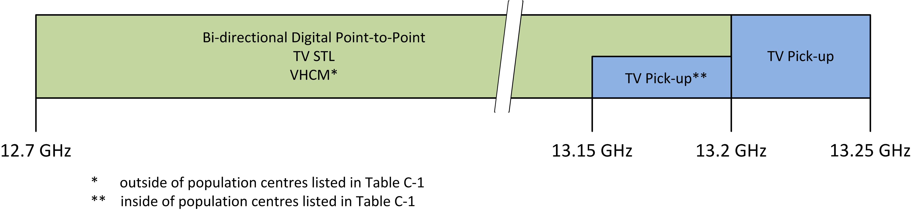

  - Definitions

Bidirectional Point-to-Point Digital Radio System – A fixed radiocommunication system used to relay digital information directly between two fixed points, in both directions.

TV Studio-to-Transmitter Links (STL) – A fixed radiocommunication system used to relay television program material and related communications from the studio to the transmitter site of a television broadcast station.

Very High Capacity Microwave (VHCM) – A fixed radiocommunication system used for the transmission of television and related audio signals for the purpose of CATV distribution.

    - TV Pick-up – A fixed radiocommunication system between a temporary remote television camera location and the studio. A TV Pick-up may consist of a camera to transportable studio link (transportable to transportable) and a transportable studio to TV broadcast studio link (transportable to point).

Channel Spacing – frequency separation between centre frequencies of adjacent channels within the same channel plan.

  - Geographical Sharing

Licensing of new VHCM systems is limited to geographical locations outside of population centres listed in Table C-1 of Annex C. On a case-by-case basis and at the discretion of the Department’s regional offices, ISED may consider the licensing of a new VHCM system that has the transmitter station (starting point) within and the receiver station (ending point) outside of geographical locations listed in Table C-1 of Annex C, in order to consider systems which intend to serve a remote area. In addition, for this latter new system, the co-polarized radiation pattern envelope in the horizontal plane of the antenna must remain within envelope A shown in Figure 2 and Table 2 of Section 8, for both vertical and horizontal polarizations.

Modifications to existing VHCM systems located within population centres listed in Table C-1 of Annex C will be considered on a case-by-case basis at the discretion of the Department’s regional offices.

The 13.15-13.20 GHz portion of the band is shared on a geographical basis. Within population centres listed in Table C-1 of Annex C, preference will be given to TV STL and TV Pick-up systems over bidirectional digital point-to-point and VHCM systems.

Radio Frequency (RF) Channel Arrangement Description

  - RF Channel Arrangements for Bidirectional Point-to-Point Digital Radio Systems

The channel plans defined in this standard provide for six different RF channel spacings. Channel pairs are provided with a common transmit/receive separation of 225 MHz.

The allowable channel bandwidths are:
Less than or equal to 5 MHz
Greater than 5 MHz and less than or equal to 12.5 MHz
Greater than 12.5 MHz and less than or equal to 25 MHz
Greater than 25 MHz and less than or equal to 30 MHz
Greater than 30 MHz and less than or equal to 40 MHz
Greater than 40 MHz and less than or equal to 50 MHz

    - RF Channel Centre Frequencies

      - 5 MHz Channel Spacing

The centre frequencies of the 45 paired channels which allow RF channel bandwidths less than or equal to 5 MHz are expressed by the following relationships:

Lower half of the band A_{n} = 12697.5 + 5n for n = 1 to 45
Upper half of the band A′_{n} = 12922.5 + 5n for n = 1 to 45

Where n is the channel number and A_{n} and A′_{n} are the centre frequencies in MHz of the paired channels. The 45 centre frequencies for the paired channels are summarised in Annex B, table B-1.

      - 12.5 MHz Channel Spacing

The centre frequencies of the 18 paired channels which allow RF channel bandwidths greater than 5 MHz and less than or equal to 12.5 MHz are expressed by the following relationships:

Lower half of the band B_{n} = 12693.75 + 12.5n for n = 1 to 18
Upper half of the band B′_{n} = 12918.75 + 12.5n for n = 1 to 18

Where n is the channel number and B_{n} and B′_{n} are the centre frequencies in MHz of the paired channels. The 18 centre frequencies for the paired RF channels are summarised in Annex B, table B-2.

      - 25 MHz Channel Spacing

The centre frequencies of the 9 paired channels which allow RF channel bandwidths greater than 12.5 MHz and less than or equal to 25 MHz are expressed by the following relationships:

Lower half of the band C_{n} = 12687.5 + 25n for n = 1 to 9
Upper half of the band C′_{n} = 12912.5 + 25n for n = 1 to 9

Where n is the channel number and C_{n} and C′_{n} are the centre frequencies in MHz of the paired channels. The 9 centre frequencies for the paired RF channels are summarised in Annex B, table B-3.

      - 30 MHz Channel Spacing

The centre frequencies of the 7 paired channels which allow RF channel bandwidths greater than 25 MHz and less than or equal to 30 MHz are expressed by the following relationships:

Lower half of the band D_{n} = 12685 + 30n for n = 1 to 7
Upper half of the band D′_{n} = 12910 + 30n for n = 1 to 7

Where n is the channel number and D_{n} and D′_{n} are the centre frequencies in MHz of the paired channels. The 7 centre frequencies for the paired RF channels are summarised in Annex B, table B-4.

      - 40 MHz Channel Spacing

The centre frequencies of the 5 paired channels which allow RF channel bandwidths greater than 30 MHz and less than or equal to 40 MHz are expressed by the following relationships:

Lower half of the band E_{n} = 12680 + 40n for n = 1 to 5
Upper half of the band E′_{n} = 12905 + 40n for n = 1 to 5

Where n is the channel number and E_{n} and E′_{n} are the centre frequencies in MHz of the paired channels. The 5 centre frequencies for the paired RF channels are summarised in Annex B, table B-5.

      - 50 MHz Channel Spacing

The centre frequencies of the 4 paired channels which allow RF channel bandwidths greater than 40 MHz and less than or equal to 50 MHz are expressed by the following relationships:

Lower half of the band F_{n} = 12675 + 50n for n = 1 to 4
Upper half of the band F′_{n} = 12900 + 50n for n = 1 to 4

Where n is the channel number and F_{n} and F′_{n} are the centre frequencies in MHz of the paired channels. The 4 centre frequencies for the paired RF channels are summarised in Annex B, table B-6.

    - Branching or Spur Route Channels

The frequencies assigned to a main route system should be reused on the branching or spur routes where possible. The siting of repeater stations should be planned with this requirement in mind to ensure sufficient antenna discrimination at the branch-off angle.

    - Closed Loop

When bidirectional point-to-point digital radio systems form a closed loop, such systems must be designed to consist of an even number of hops to permit the use of two frequency plans.

    - Assignment of Frequencies

New radio systems should normally use the lowest available frequency pair that can be successfully coordinated. However, due to varying conditions and circumstances across Canada, regional offices may assign frequencies using a procedure different from the one described above, at their own discretion.

    - Spectral Efficiency

The bidirectional point-to-point digital radio systems submitted for licensing shall meet a minimum spectral efficiency of 3.0 bits/s/Hz using single polarization.

In the case of systems using adaptive modulation to maintain link availability during deep fading conditions, the spectral efficiency level may be temporarily lowered for a short period of time, provided that the link is designed to meet the minimum spectral efficiency requirements specified above.

    - Protection Channels

(a) One paired protection channel may be permitted for systems with more than one paired working channel.

(b) Quad-path diversity applications will be considered on a hop-by-hop basis to solve special propagation problems.

  - RF Channel Arrangements for Very High Capacity Microwave (VHCM) Systems

    - RF Channel Arrangements

The RF channel arrangements for VHCM systems are described in Annex A.

    - Assignment of Frequencies

Applicants are required to submit a detailed technical analysis to substantiate the number of individual RF channels required for the VHCM system, including technical information on the CATV signals supported by the VHCM system.

    - Spectral Efficiency

The digital VHCM systems submitted for licensing shall meet a minimum spectral efficiency of 3.0 bits/s/Hz using single polarization.

  - RF Channel Arrangements for TV Pick-up Systems

    - RF Channel Centre Frequencies

There are four RF channels available in the band 13.15-13.25 GHz for TV Pick-up as follows:

Channel Centre Frequency

1 13212.5 MHz
2 13237.5 MHz
3 13262.5 MHz
4 13287.5 MHz

The RF channel bandwidth for TV pick-up systems shall be equal to or less than 12 MHz. Requests for channel bandwidths greater than 12 MHz but less than 25 MHz shall require sufficient technical justification from the applicant and will be considered on a case-by-case basis at the discretion of the Department’s regional office.

TV Pick-up users will share the channels allocated to this service. They will co-ordinate their use on an event basis.

TV Pick-up from mobile platforms (land, water or airborne) can be approved on the condition that such use is temporary and has been coordinated with other fixed service users in the affected geographic area.

Transmitter Characteristics

  - Transmitter Characteristics for Bidirectional Point-to-Point Digital Radio Systems

    - Transmitter Power Limits

The transmitter power delivered to the antenna input shall not exceed 10 watts (+10 dBW) per RF channel.

In the case of systems using automatic transmit power control (ATPC) to maintain link availability during deep fading conditions, the maximum transmitter power at the antenna port may be temporarily increased by a value corresponding to the ATPC range, up to a maximum 10 watts. In addition, the maximum e.i.r.p. limits indicated in Section 9 of this document shall be met at all times.

    - Frequency Stability

The centre frequency of the emission shall be maintained within 0.005% of the assigned or reference frequency.

    - Emission Limits

- In any 4 kHz band, where the centre frequency is removed from the assigned frequency by more than 50% up to and including 250% of the authorized bandwidth, the mean power of emission shall be attenuated below the mean output power of the transmitter in accordance with the following equation.

A = 35 + 0.8 (P - 50) + 10 log₁₀ B

where

A = attenuation (in dB) below the mean output power level
P = percent removed from the centre frequency of the assigned RF channel
B = authorized bandwidth (in MHz)

Note: 1. In no case shall the attenuation be less than 50 dB.
2. Attenuation greater than 80 dB or to an absolute power of less than -13 dBm/MHz is not necessary.

- In any 1 MHz band, where the centre frequency is removed from the assigned frequency by more than 250% of the authorized bandwidth the mean power of emission shall be attenuated by 43 + 10 log ₁₀ (mean output power in watts) dB or 80 dB, whichever is the lesser attenuation.

  - Transmitter Characteristics for VHCM and TV Pick-up Systems

    - Transmitter Power Limits

The transmitter power delivered to the antenna input shall not exceed 10 watts (+10 dBW) per RF channel.

6.2.2 Frequency Stability

The centre frequency of the emission shall be maintained within 0.005% of the assigned or reference frequency.

6.2.3 Emission Limits

All significant emissions from the transmitter, including at least 99% of the transmitted power, shall be contained within the authorized bandwidth.

International Coordination

Stations operating in the band 12.7-13.25 GHz near the Canada-United States border are subject to the provisions of Arrangement A.

Antenna Characteristics

  - Antenna Characteristics for Bidirectional Point-to-Point Digital Radio, VHCM, and TV Pick-up Systems

The co-polarized radiation pattern envelope in the horizontal plane of the antenna must remain within envelope B shown in Figure 2 and Table 2, for both vertical and horizontal polarizations.

Figure 2 – Minimum Antenna Characteristics for Bidirectional Point-to-Point Digital Radio and VHCM Systems Operating in the Band 12.7-13.20 GHz and TV Pick-up systems Operating in the Frequency Band 13.15-13.25 GHz
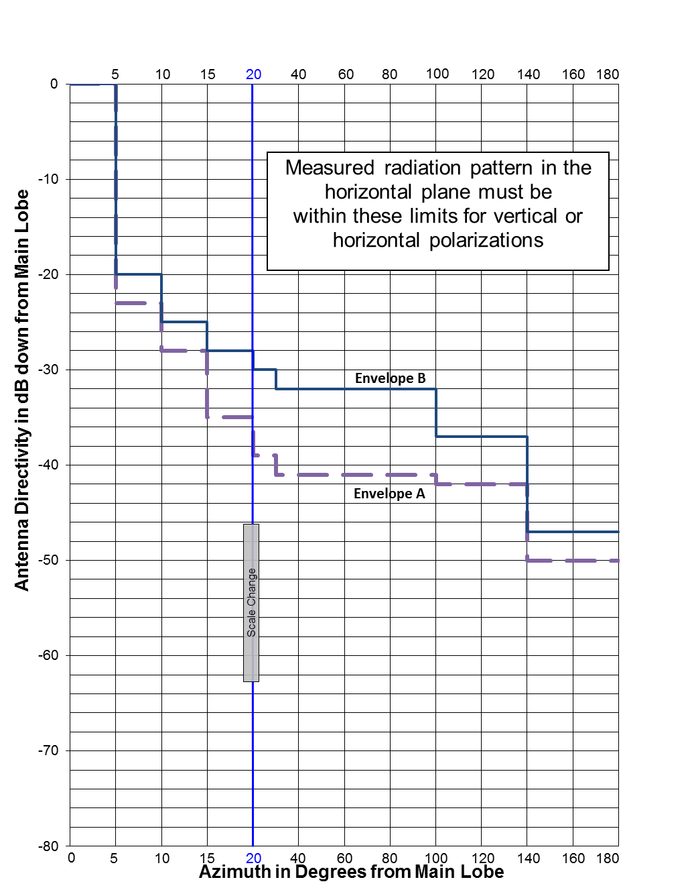

Table 2: Minimum Antenna Characteristics for Bidirectional Point-to-Point Digital Radio and VHCM Systems Operating in the Band 12.7-13.20 GHz and TV Pick-up systems Operating in the Frequency Band 13.15-13.25 GHz
Azimuth in Degrees from Main Lobe Peak | Antenna Directivity Co-polarization  (Decibels Down from Main Lobe Peak)
Azimuth in Degrees from Main Lobe Peak | Envelope A | Envelope B
0° - 5° | 0 | 0
5° - 10° | 23 | 20
10° - 15° | 28 | 25
15° - 20° | 35 | 28
20° - 30° | 39 | 30
30° - 100° | 41 | 32
100° - 140° | 42 | 37
140° - 180° | 50 | 47

Maximum Equivalent Isotropically Radiated Power

The maximum equivalent isotropically radiated power (e.i.r.p.) from the antenna of a bidirectional point-to-point digital radio transmitter shall not in any case exceed +50 dBW per RF channel.

The maximum e.i.r.p. from the antenna of a VHCM transmitter shall not in any case exceed +55 dBW per RF channel.

The maximum e.i.r.p. from the antenna of a TV Pick-up transmitter shall not in any case exceed +45 dBW per RF channel.

Enhanced Technical Standards for Bidirectional Point-to-Point Digital Radio Systems in Moderately Congested and Highly Congested Areas

For new radio systems being deployed in moderately congested or highly congested areas, the co-polarized radiation pattern envelope in the horizontal plane of the antenna must remain within envelope A shown in Figure 2 and Table 2 of Section 8, for both vertical and horizontal polarizations.

Protection channels for radio systems operating in congested areas are not permitted. For channels requirements in uncongested areas, see Section 5.1.6 of this document.

Systems submitted for licensing shall have a minimum spectral efficiency of 4.4 bits/s/Hz within the RF channel bandwidth on a single polarization.

Avoidance of the Geostationary Satellite Orbit

As far as practicable, sites for transmitting terrestrial stations in the fixed service, employing maximum values of e.i.r.p. exceeding +45 dBW in the frequency band 12.7-13.25 GHz, should be selected so that the direction of maximum radiation of any antenna will be at least 1.5º away from the geostationary-satellite orbit, taking into account the effect of atmospheric refraction.

Annex A: Channel Arrangement for VHCM Systems

VHCM systems shall use channels spaced at 6 MHz (see Figure A-1), corresponding to VHF television channelling on cable systems in accordance with ICES-008.

Figure A-1 – Channel Arrangement for VHCM (80 Channel Systems)
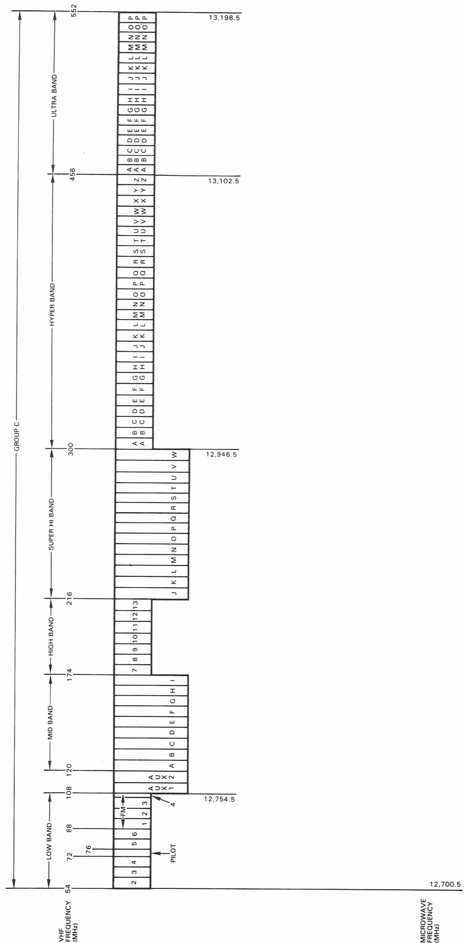

Annex B: Channel Arrangements for Bidirectional Point-to-Point Digital Radio Systems

Channel Arrangement Centre Frequencies for Bidirectional Point-to-Point Digital Radio Systems

Table B-1 Centre Frequencies for 5 MHz channel spacing
Channel | Lower Channel Centre Frequency (MHz) | Upper Channel Centre Frequency (MHz)
A1 / A1' | 12702.5 | 12927.5
A2 / A2' | 12707.5 | 12932.5
A3 / A3' | 12712.5 | 12937.5
A4 / A4' | 12717.5 | 12942.5
A5 / A5' | 12722.5 | 12947.5
A6 / A6' | 12727.5 | 12952.5
A7 / A7' | 12732.5 | 12957.5
A8 / A8' | 12737.5 | 12962.5
A9 / A9' | 12742.5 | 12967.5
A10 / A10' | 12747.5 | 12972.5
A11 / A11' | 12752.5 | 12977.5
A12 / A12' | 12757.5 | 12982.5
A13 / A13' | 12762.5 | 12987.5
A14 / A14' | 12767.5 | 12992.5
A15 / A15' | 12772.5 | 12997.5
A16 / A16' | 12777.5 | 13002.5
A17 / A17' | 12782.5 | 13007.5
A18 / A18' | 12787.5 | 13012.5
A19 / A19' | 12792.5 | 13017.5
A20 / A20' | 12797.5 | 13022.5
A21 / A21' | 12802.5 | 13027.5
A22 / A22' | 12807.5 | 13032.5
A23 / A23' | 12812.5 | 13037.5
A24 / A24' | 12817.5 | 13042.5
A25 / A25' | 12822.5 | 13047.5
A26 / A26' | 12827.5 | 13052.5
A27 / A27' | 12832.5 | 13057.5
A28 / A28' | 12837.5 | 13062.5
A29 / A29' | 12842.5 | 13067.5
A30 / A30' | 12847.5 | 13072.5
A31 / A31' | 12852.5 | 13077.5
A32 / A32' | 12857.5 | 13082.5
A33 / A33' | 12862.5 | 13087.5
A34 / A34' | 12867.5 | 13092.5
A35 / A35' | 12872.5 | 13097.5
A36 / A36' | 12877.5 | 13102.5
A37 / A37' | 12882.5 | 13107.5
A38 / A38' | 12887.5 | 13112.5
A39 / A39' | 12892.5 | 13117.5
A40 / A40' | 12897.5 | 13122.5
A41 / A41' | 12902.5 | 13127.5
A42 / A42' | 12907.5 | 13132.5
A43 / A43' | 12912.5 | 13137.5
A44 / A44' | 12917.5 | 13142.5
A45 / A45' | 12922.5 | 13147.5

Table B-2 Centre Frequencies for 12.5 MHz channel spacing
Channel | Lower Channel Centre Frequency (MHz) | Upper Channel Centre Frequency (MHz)
B1 / B1' | 12706.25 | 12931.25
B2 / B2' | 12718.75 | 12943.75
B3 / B3' | 12731.25 | 12956.25
B4 / B4' | 12743.75 | 12968.75
B5 / B5' | 12756.25 | 12981.25
B6 / B6' | 12768.75 | 12993.75
B7 / B7' | 12781.25 | 13006.25
B8 / B8' | 12793.75 | 13018.75
B9 / B9' | 12806.25 | 13031.25
B10 / B10' | 12818.75 | 13043.75
B11 / B11' | 12831.25 | 13056.25
B12 / B12' | 12843.75 | 13068.75
B13 / B13' | 12856.25 | 13081.25
B14 / B14' | 12868.75 | 13093.75
B15 / B15' | 12881.25 | 13106.25
B16 / B16' | 12893.75 | 13118.75
B17 / B17' | 12906.25 | 13131.25
B18 / B18' | 12918.75 | 13143.75

Table B-3 Centre Frequencies for 25 MHz channel spacing
Channel | Lower Channel Centre Frequency (MHz) | Upper Channel Centre Frequency (MHz)
C1 / C1' | 12712.5 | 12937.5
C2 / C2' | 12737.5 | 12962.5
C3 / C3' | 12762.5 | 12987.5
C4 / C4' | 12787.5 | 13012.5
C5 / C5' | 12812.5 | 13037.5
C6 / C6' | 12837.5 | 13062.5
C7 / C7' | 12862.5 | 13087.5
C8 / C8' | 12887.5 | 13112.5
C9 / C9' | 12912.5 | 13137.5

Table B-4 Centre Frequencies for 30 MHz channel spacing
Channel | Lower Channel Centre Frequency (MHz) | Upper Channel Centre Frequency (MHz)
D1 / D1' | 12715 | 12940
D2 / D2' | 12745 | 12970
D3 / D3' | 12775 | 13000
D4 / D4' | 12805 | 13030
D5 / D5' | 12835 | 13060
D6 / D6' | 12865 | 13090
D7 / D7' | 12895 | 13120

Table B-5 Centre Frequencies for 40 MHz channel spacing
Channel | Lower Channel Centre Frequency (MHz) | Upper Channel Centre Frequency (MHz)
E1 / E1' | 12720 | 12945
E2 / E2' | 12760 | 12985
E3 / E3' | 12800 | 13025
E4 / E4' | 12840 | 13065
E5 / E5' | 12880 | 13105

Table B-6 Centre Frequencies for 50 MHz channel spacing
Channel | Lower Channel Centre Frequency (MHz) | Upper Channel Centre Frequency (MHz)
F1 / F1' | 12725 | 12950
F2 / F2' | 12775 | 13000
F3 / F3' | 12825 | 13050
F4 / F4' | 12875 | 13100

Annex C: Areas for Implementation of Geographical Sharing among Bidirectional Point-to-Point Digital Radio, TV Pick-up, and VHCM Systems

Table C-1 lists medium and large population centres with population greater than 30,000, as reported by the Statistics Canada 2016 Census Program. The boundary files for population centres can be downloaded from the Statistics Canada website.

The precise application of geographical sharing requirements outlined in this SRSP, specifically near and around population centres listed in Table C-1, shall be made at the discretion of the Department’s regional office, on a case-by-case basis.

Table C-1: Listing of medium and large population centres
No. | ID | NAME | Province
1 | 792 | St. John's | Newfoundland and Labrador / Terre-Neuve-et-Labrador
2 | 159 | Charlottetown | Prince Edward Island / Île-du-Prince-Édouard
3 | 348 | Halifax | Nova Scotia / Nouvelle-Écosse
4 | 240 | Drummondville | Quebec / Québec
5 | 328 | Granby | Quebec / Québec
6 | 305 | Fredericton | New Brunswick / Nouveau-Brunswick
7 | 539 | Moncton | New Brunswick / Nouveau-Brunswick
8 | 734 | Saint John | New Brunswick / Nouveau-Brunswick
9 | 176 | Chicoutimi - Jonquière | Quebec / Québec
10 | 63 | Beloeil | Quebec / Québec
11 | 396 | Joliette | Quebec / Québec
12 | 685 | Québec | Quebec / Québec
13 | 547 | Montréal | Quebec / Québec
14 | 616 | Ottawa - Gatineau | Quebec / Québec
15 | 834 | Saint-Hyacinthe | Quebec / Québec
16 | 836 | Saint-Jean-sur-Richelieu | Quebec / Québec
17 | 842 | Saint-Jérôme | Quebec / Québec
18 | 709 | Rimouski | Quebec / Québec
19 | 750 | Shawinigan | Quebec / Québec
20 | 758 | Sherbrooke | Quebec / Québec
21 | 770 | Sorel | Quebec / Québec
22 | 953 | Trois-Rivières | Quebec / Québec
23 | 971 | Salaberry-de-Valleyfield | Quebec / Québec
24 | 987 | Victoriaville | Quebec / Québec
25 | 1177 | Châteauguay | Quebec / Québec
26 | 87 | Bowmanville | Ontario
27 | 314 | Georgetown | Ontario
28 | 92 | Brantford | Ontario
29 | 43 | Barrie | Ontario
30 | 61 | Belleville | Ontario
31 | 480 | London | Ontario
32 | 167 | Chatham | Ontario
33 | 205 | Cornwall | Ontario
34 | 463 | Leamington | Ontario
35 | 788 | St. Catharines - Niagara Falls | Ontario
36 | 799 | St. Thomas | Ontario
37 | 897 | Stratford | Ontario
38 | 532 | Milton | Ontario
39 | 343 | Guelph | Ontario
40 | 349 | Hamilton | Ontario
41 | 399 | Kanata | Ontario
42 | 415 | Kingston | Ontario
43 | 419 | Kitchener | Ontario
44 | 595 | North Bay | Ontario
45 | 609 | Orangeville | Ontario
46 | 610 | Orillia | Ontario
47 | 904 | Sudbury | Ontario
48 | 935 | Thunder Bay | Ontario
49 | 614 | Oshawa | Ontario
50 | 616 | Ottawa - Gatineau | Ontario
51 | 636 | Peterborough | Ontario
52 | 737 | Sarnia | Ontario
53 | 739 | Sault Ste. Marie | Ontario
54 | 1020 | Stouffville | Ontario
55 | 1032 | Windsor | Ontario
56 | 1039 | Woodstock | Ontario
57 | 944 | Toronto | Ontario
58 | 678 | Prince Albert | Saskatchewan
59 | 698 | Regina | Saskatchewan
60 | 3 | Airdrie | Alberta
61 | 115 | Calgary | Alberta
62 | 694 | Red Deer | Alberta
63 | 119 | Campbell River | British Columbia / Colombie-Britannique
64 | 177 | Chilliwack | British Columbia / Colombie-Britannique
65 | 207 | Courtenay | British Columbia / Colombie-Britannique
66 | 478 | Lloydminster | Alberta
67 | 568 | Nanaimo | British Columbia / Colombie-Britannique
68 | 292 | Fort McMurray | Alberta
69 | 549 | Moose Jaw | Saskatchewan
70 | 397 | Kamloops | British Columbia / Colombie-Britannique
71 | 403 | Kelowna | British Columbia / Colombie-Britannique
72 | 478 | Lloydminster | Saskatchewan
73 | 780 | Spruce Grove | Alberta
74 | 738 | Saskatoon | Saskatchewan
75 | 1528 | Welland - Pelham | Ontario
76 | 983 | Vernon | British Columbia / Colombie-Britannique
77 | 984 | Victoria | British Columbia / Colombie-Britannique
78 | 1021 | White Rock | British Columbia / Colombie-Britannique
79 | 1048 | Abbotsford | British Columbia / Colombie-Britannique
80 | 467 | Lethbridge | Alberta
81 | 1560 | Mission | British Columbia / Colombie-Britannique
82 | 91 | Brandon | Manitoba
83 | 1036 | Winnipeg | Manitoba
84 | 252 | Edmonton | Alberta
85 | 523 | Medicine Hat | Alberta
86 | 336 | Grande Prairie | Alberta
87 | 632 | Penticton | British Columbia / Colombie-Britannique
88 | 679 | Prince George | British Columbia / Colombie-Britannique
89 | 973 | Vancouver | British Columbia / Colombie-Britannique

For the purposes of this SRSP, “harmful interference” means interference that endangers the functioning of a radionavigation service or of other safety services or seriously degrades, obstructs, or repeatedly interrupts a radiocommunication service operating in accordance with regulations and technical requirements laid down by the Minister of Industry under the Radiocommunications Act.
Quad-path diversity refers to the use of frequency diversity and space diversity on the same path
Requirements related to envelope A are addressed in Section 10 of this SRSP.
Requirements related to envelope A are addressed in Section 10 of this SRSP.
ITU-R Recommendation SF.765 provides guidance on calculating the intersection of radio-relay antenna beams with orbits used by space stations in the fixed-satellite service.
https://www12.statcan.gc.ca/census-recensement/2011/geo/bound-limit/bound-limit-2016-eng.cfm

